Daniela Arrospide | Capstone in Informatics

IT General Controls Compliance Analyzer
Introduction
This capstone paper details my journey from the initial vision to the creation of an IT General Controls Compliance Analyzer prototype.
At the beginning of the project, my idea was larger and more open-ended. I wanted to build a tool that could take almost any type of compliance-related text, analyze it, and turn it into a dashboard that every day users could understand. My original vision was a system that could read high level compliance requests and compare them against employee narratives regarding their processes. The system would then identify possible compliance issues, assign risk levels, and present the results visually in a way that made complex information easier to understand and ultimately, act on – a cornerstone of something I learned in this program.
As the project developed, I realized that the original idea needed a clearer and more realistic scope. My initial vision was for the system to handle large SOX and ITGC spreadsheets, compare those control requirements against synthetic interview styled evidence, and then turn the results into an easy to understand dashboard. The synthetic interview style text remained an important part of the project because real compliance reviews often depend on explanations from various different employees at different levels in each company and not each employee will respond with the same level of clarity or know-how when asked these complicated controls. What changed was the size and flexibility of the control side. Instead of trying to make the tool read any control spreadsheet or PDF automatically, I narrowed the project to ten focused, real-world ITGC controls. This gave the prototype a stronger foundation because I could build and test the rules more carefully. In the future, the same idea could be expanded into a larger system that reads full SOX matrices, ITGC spreadsheets, or PDF control documents and compares them against narrative process responses. That future version may require AI, but this prototype helped make the larger vision easier to see.
The final project became a prototype compliance analyzer that evaluates narrative, interview-style evidence against a structured ITGC control library. The tool classifies each control as Passed, Failed, or Needs Review, then presents the results through a Streamlit dashboard. While the final version is smaller than my original vision, it became more realistic, explainable, and useful as a capstone project. Instead of trying to solve every compliance problem, it demonstrates how unstructured human responses can be mapped to structured control rules and turned into clear business findings.
This project also reflects many of the skills I developed throughout my master’s program. It required synthetic data creation, data cleaning, rules-based logic, algorithm testing, accuracy testing/review, tree map visualizations and much more. The work began in Jupyter Notebook as a way to test the analyzer logic and later moved into Visual Studio Code and Streamlit to create a user-facing application. This progression helped me understand how a technical idea can move from experiment to prototype.
To me this capstone has become more than just it’s final product. It has been about taking the tools I learned at TWU and applying them to a real life creation. The real life application of everything learned is something that has been incredibly valuable to me and has let me see the possibilities that lay in front of me.

Business Problem and Project Purpose
The purpose of this project is to create a tool that helps companies and everyday users understand where they stand with ITGC compliance before an external audit begins.
This brings us to our real world problem. In many organizations, compliance information can be difficult to understand because it is stored in large matrices, spreadsheets, text based audit requests from external auditor portals etc. These mediums may contain important information, but they are not always easy for the non-technical user or every day employee to interpret quickly.
SOX and ITGC control matrices can become large and complex. Even when a company has these documents, it may not have an easy way to quickly understand which controls are healthy, which ones are weak, and which ones need additional evidence. Because of this, companies may not discover control deficiencies until an external audit is already in progress. By that point, the organization may be under pressure to locate documentation, explain missing evidence, or correct issues after they have already become audit concerns.
This project is also connected to my own professional experience. I have worked in audit and compliance for well over a decade, and I have seen firsthand how important strong controls are to an organization. I have also seen the pressure companies can face when audit issues are discovered late in the process. A failed audit or significant deficiency can create real consequences and ultimately increased scrutiny and loss of confidence in internal processes and employees. Because of this, I understand just how critical compliance is for any organization. It is part of how a company protects its systems, data, financial processes, and overall trust.
Therefore after identifying this business need and problem, this project’s purpose became to design an internal audit preparation tool. The idea is that a company could use prior year ITGCs, current control requirements, or internal compliance questions as a starting point and compare them against process explanations or interview style responses from employees. Instead of waiting until the external auditor identifies the problem, the company could use the analyzer to perform an early internal check. This would help the company see whether the submitted evidence appears strong, weak, or unclear before the formal audit process begins.
The other main focus of the project is usability. As we have learned throughout this master’s program, a tool is only helpful if people can understand the results. For this reason, the final prototype focuses on an easy to understand dashboard that can turn complicated compliance information into clear visual results.
Overall, the tool is not meant to replace external auditors. It is meant to be a first pass internal review tool that helps companies prepare earlier and identify focus points for future external audits. To me, this is the real purpose of the project: making complex compliance information easier to see, understand, and act on before it becomes a bigger problem.

Track B | The Builder - Project Scope and Data Strategy
From conception it was clear to me that this would need to have a clear prototype that used a combination of real data and synthetic data, as a deliverable in the end. Because of this Track B, “The Builder” was the path I chose.
Since real ITGC audit evidence can include sensitive company information and internal process documentation, it would not have been appropriate to use real company data for this capstone. Synthetic data allowed me to safely create realistic compliance scenarios without exposing private or confidential information.
The project was built around two main datasets: a structured ITGC control library created from existing audit requests in the company I previously worked for, and synthetic evidence datasets. The control library represents the rules the analyzer checks against. Each control includes a control ID, control category, control description, required keywords, optional keywords, failure indicators, severity, and domain grouping. The evidence datasets represent interview style responses or process explanations that a company might collect during an internal compliance review. Each evidence record is connected to a specific control ID so the analyzer can compare the submitted evidence to the correct control requirement.
For the scope of this prototype, I narrowed the analyzer to ten real world ITGC controls as shown below:
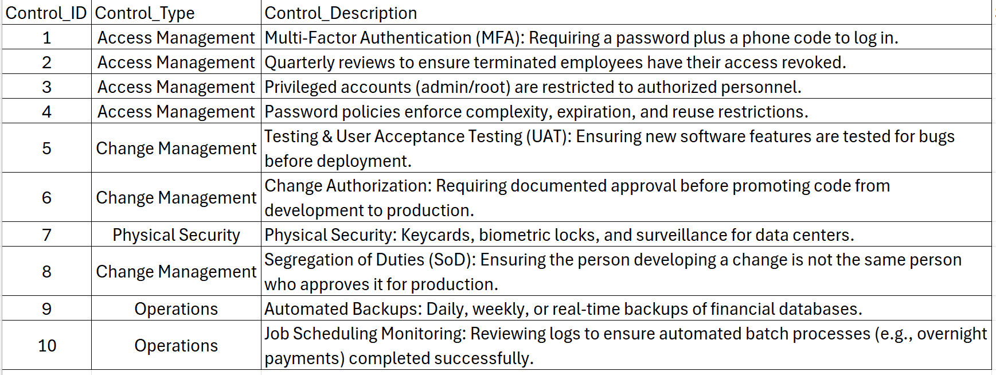
Figure 1. 10 ITGC controls with Control ID and Control Type.
These controls were selected because they represent common areas reviewed during IT audit and compliance work.
The ten controls included correspond to the following business areas:
- Multi-Factor Authentication
- Quarterly access reviews for terminated employees
- Privileged account restrictions
- Password policy requirements
- Testing and User Acceptance Testing
- Change authorization
- Physical security
- Segregation of duties
- Automated backups
- Job scheduling monitoring

Together, these controls gave the prototype enough variety to test access management, change management, security, backup, and monitoring scenarios without making the project too large to complete.
The synthetic evidence was created to represent different levels of compliance clarity. Some evidence statements were written to clearly support the control, some were written to clearly show a gap, and others were intentionally unclear or incomplete. This was important because real audit conversations are not universal or consistent. A control owner may provide a strong answer, a weak answer, or an answer that needs follow-up. Because of this, the analyzer needed three possible outcomes: Passed, Failed, and Needs Review.
After initial testing and completion of the analyzer, I tested the analyzer with different evidence scenarios that I prepared for my demo. These included a mostly compliant dataset, a mixed-risk dataset, and a needs-review dataset. This helped validate that the prototype was not designed for only one outcome. The goal was to show that the analyzer could respond differently depending on the evidence provided.
This scope helped keep the project realistic while still supporting the larger vision. The final prototype does not automatically read any SOX spreadsheet or PDF control matrix, but it demonstrates the core process that would be needed for that type of future system. The control library also included a domain grouping field, however, the final prototype primarily used the control type field. Domain grouping remains available in the data structure and could be expanded in a future version for more detailed reporting.
In summary, this capstone shows how structured control requirements can be compared against narrative evidence, scored through rule-based logic, and then displayed in a dashboard that business users can understand.

Jupyter Notebook Development and Early Algorithm Testing
The first technical phase of this project began in Jupyter Notebook. Before building the final dashboard in Streamlit, I needed a space where I could test the analyzer logic step by step and see how well it performed. Jupyter Notebook was the starting point for the project because it allowed me to work closely with the data, perform trial and error, adjust the rules, and the key benefit was seeing the results immediately output after each change was made. I have also been most comfortable with Jupyter Notebook as we have frequently used it throughout this master’s program. This made it the best environment for experimenting.
Through guidance in our capstone course, I had already determined the ten real world ITGC controls that I had obtained from previous ITGC audits at my then, current employer. So these ten controls served as the starting point for the analyzer.
From there, the next step was to translate those real controls into a format the code could evaluate.
To make the controls usable for the analyzer, I organized each control into fields such as Control ID, Control Type, Domain Group, Control Description, Required Keywords, Optional Keywords, Failure Indicators, and Severity. This step was important because it turned the controls into a control library that could be used by the algorithm.
The notebook then used this structured control library with an initial synthetic evidence dataset. This dataset contained 30 narrative or “interview style” evidence records designed specifically for testing the algorithm. The records were balanced across three expected outcomes: PASS, FAIL, and UNKNOWN, with 10 examples of each. This was important because the analyzer needed to recognize more than one type of response. It had to identify strong evidence that supported a control, weak evidence that showed a possible gap, and unclear evidence that would need additional review.
I would also like to note that this initial Jupyter test dataset was different from the evidence datasets later used in the final Streamlit demo.
In summary, the notebook dataset was created for development and rule refinement, while the later demo datasets were created to best showcase different business scenarios in the dashboard.

As work on the project began, the Jupyter notebook phase also revealed that the first version of the analyzer was not very accurate. In the early stages, the model accuracy was only around 31%. There were even times when the model accuracy completely dropped to 0%. This low result was important because it showed that simple keyword matching by itself was not enough to fulfil the vision of the project and so the notebook stage became a cycle of testing, reviewing errors, and refining the rule logic.
Logical flow of the Jupyter Notebook algorithm:
- Load the control library and evidence dataset
  - The notebook began by loading the structured ITGC control library and the synthetic evidence dataset into pandas dataframes
- Clean and standardize the text
  - Evidence text was converted to lowercase, cleaned of extra punctuation or spacing and normalized
- Match evidence to the correct control
  - Each evidence record was linked to its corresponding control using the control ID
- Check for required keywords, optional keywords, and failure indicators
  - The analyzer searched the evidence for expected terms tied to each control.
  - Required keywords represented stronger evidence of compliance, optional keywords provided supporting signals, and failure indicators pointed to possible control weaknesses.
- Apply weighted scoring
  - The algorithm calculated a score using the following logic:
  - Score = (Required Matches × 2) + (Optional Matches × 1) − (Failure Matches × 3)
- Classify the result
  - Based on the score and the matched terms, the analyzer assigned each evidence a status of PASS, FAIL, or UNKNOWN
- Compare predicted status to expected status
  - The notebook then compared the analyzer’s predicted result (assigned by me) to the expected result in order to measure accuracy

One of the most important parts of the Jupyter phase was learning that the presence of a keyword was not enough. The analyzer had to be improved so it could better understand when evidence was actually describing a problem. This led to refinements in the logic, specifically the creation of failure indicators and negation handling. For example, a phrase such as “not reviewed” should not be treated the same as “reviewed,” even though both contain the same core word. Working through these issues helped make the analyzer more realistic and much stronger than its earliest version.
After multiple rounds of refinement, the notebook reached a final accuracy of 1.0, or 100% on the controlled synthetic test dataset. The final results showed exact agreement between expected and predicted outcomes: 10 FAIL results correctly predicted as FAIL, 10 PASS results correctly predicted as PASS, and 10 UNKNOWN results correctly predicted as UNKNOWN.
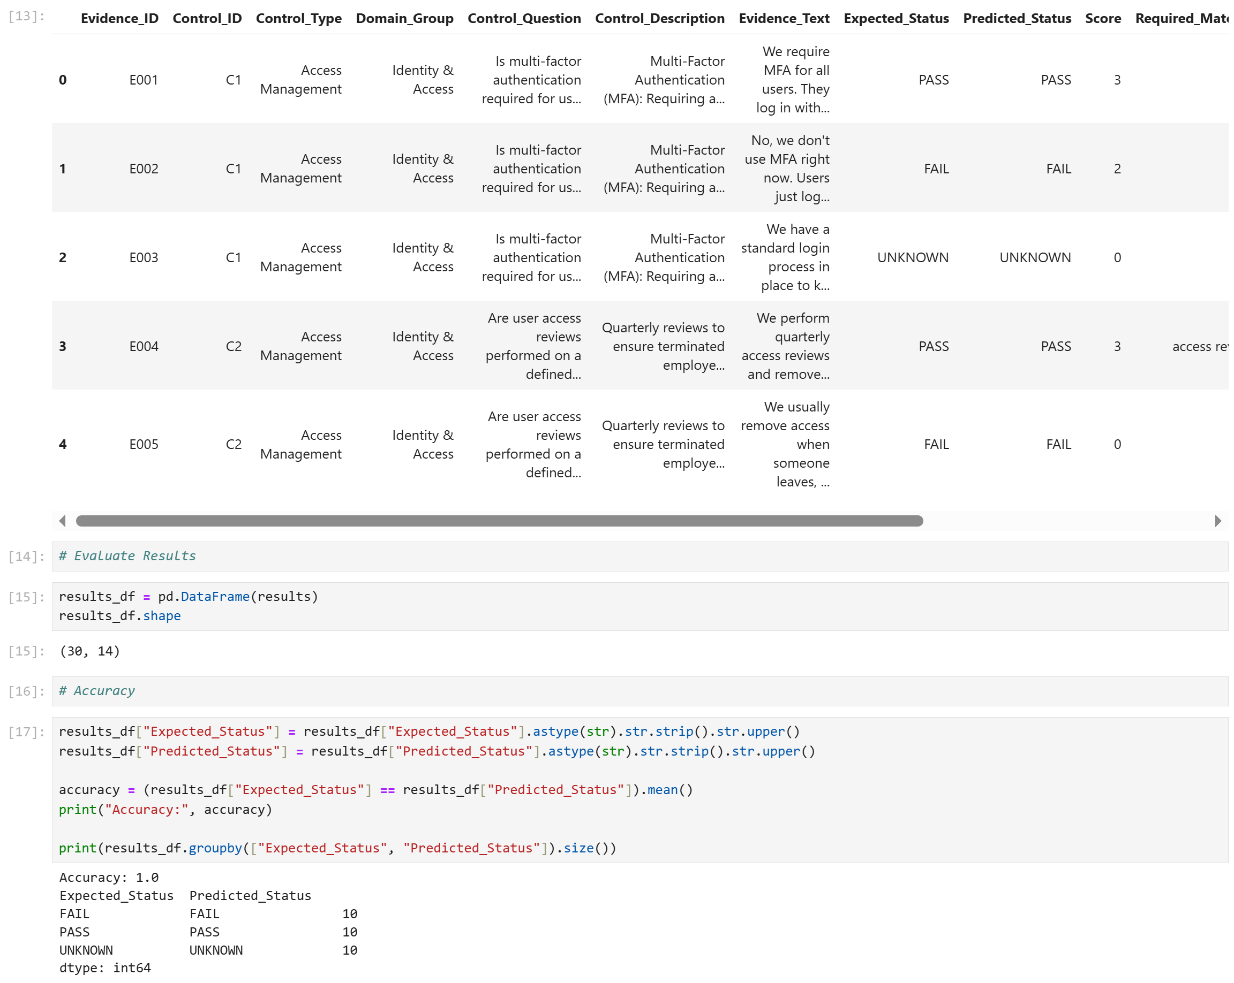
Figure 2. Final Jupyter Notebook test results showing 100% accuracy across the 30-record synthetic evidence dataset.
This result demonstrated that the rule-based logic was able to correctly classify the designed test cases. While this does not mean the analyzer would automatically be perfect on all future real-world evidence, it showed that the core logic was strong enough to move into the next phase of development.
This was an important transition point in the project. Once I could see that the analyzer was capable of comparing narrative evidence against structured ITGC controls, I could truly visualize what I wanted the final tool to become. The Jupyter Notebook phase gave me the space to build, test, challenge, and improve the analyzer logic before focusing on the dashboard. Once that foundation was achieved, I was ready to move from a testing environment into Visual Studio Code and Streamlit, where the project could become the prototype I had been imagining.
Moving from Jupyter Notebook to Streamlit
After the analyzer logic was tested in Jupyter Notebook, the next step was to turn the project into something a user could actually interact with.
This is where the project shifted from algorithm testing to application development. I moved the project into Visual Studio Code and began building the final prototype with Streamlit. Streamlit was a good fit because it allowed me to create an application dashboard using Python while still keeping the project manageable. This supported the purpose of the capstone because the goal was not only to build a working analyzer, but to make the results understandable to business users and employees who may not have a compliance background.
The move to Streamlit also changed the way I thought about the project. In Jupyter Notebook, my focus had been intensely set on whether the algorithm could correctly classify the evidence. In Streamlit, the focus completely shifted and expanded to include the user experience. This meant thinking about page layout, visual summaries, and various other things all designed to visualize results in a way that was user friendly.
This transition connected directly back to my original vision and this is where the project eventually became a fully working internal dashboard where a user could upload a control library and evidence file, run the analysis, and quickly see the company’s compliance position through clear results such as Passed, Failed, and Needs Review.

Final Prototype Code Structure and Application Design
The final application was built in Python using Visual Studio Code for Streamlit. During this phase of the project, the analyzer became an interactive front end application.
The main VS application file was created and reworked into several parts. As the work continued and progress was made, the final code sections became:
- Imports
- Brand Header
- Text Cleaning & Preprocessing
- Core (of) Analyzer Engine
- File Upload & Data Loading
- Region Output
- Run Analysis or (Analysis Execution)
- Compliance Risk Treemap
- Business Interpretation
- Priority Action Plan
- 10-Control Review Snapshot
- Company Focus Area
- Detailed Findings
- Download

Organizing the code this way helped me manage the large code sections and allowed me to move back and forth in the code more readily as changes were needed and the dashboard was tweaked.
The application begins by importing the tools needed to support the vision of my project. Streamlit creates the dashboard interface, pandas loads and processes the CSV files and regular expressions help clean and standardize the text. Plotly is used later in the application to create the compliance risk tree map. A large portion of my focus was dedicated to perfecting the look and feel of the analyzer. Because of this and in addition to these libraries, the code includes CSS styling for the dashboard layout, metric cards, status colors, priority action cards, and snapshot sections.
Through all of these pieces, we are ultimately left with a final prototype that functions by uploading files, performing analysis, and displaying user friendly results.

The first major functional layer of the code is text cleaning and preprocessing. The clean_text() function prepares evidence text before it is analyzed. It performs tasks like, converting text to lowercase, removing unnecessary punctuation, normalizing apostrophes, and removes extra spaces in order to make the evidence easier to compare against control keywords.
This step is important because interview style evidence can be written in many different ways. A user may write a sentence with different capitalization, punctuation, or spacing, but the analyzer still needs to evaluate it consistently.
The code also includes a split_keywords() function. This function takes keyword strings that are separated by commas converts them into usable keyword lists. This allows each control to have its own required keywords, optional keywords, and failure indicators. This allows the control library to become more than just a description and categorization of each control. Through this function, it becomes a structured rule source that the analyzer uses to evaluate submitted evidence.
The core of the application is the analyze_evidence_against_control() function. This function evaluates one evidence statement against one control from the control library. It first cleans the evidence text, then extracts the required keywords, optional keywords, and failure indicators for that control. The analyzer then checks which of those terms appear in the submitted evidence.
Required keyword matches represent stronger evidence that a control is being performed. Optional keyword matches provide supporting context and failure indicator matches suggest that the control may be missing, inadequate, or contradicted.
The analyzer then calculates a weighted score using the same general scoring idea tested during the Jupyter phase:
Score = (Required Matches × 2) + (Optional Matches × 1) − (Failure Matches × 3)
This scoring approach helps the analyzer avoid treating all words equally. Here we can see that required matches matter more than optional matches, while failure indicators carry a stronger negative impact. This logic makes the analyzer consider the role each term plays in the compliance decision.
The final Streamlit version also includes global review indicators and contextual negation detection. The global review indicator includes phrases such as “not documented”, “not sure”, “cannot confirm”, and “unclear”, to name a few. These phrases do not always prove that a control failed, but they do suggest that the evidence may not be strong enough to confirm compliance. In the dashboard, this type of result would be shown as “Needs Review.”
Contextual negation detection was one of the more important improvements in the final code. The application checks for negation words such as “no”, “not”, “dont”, “doesnt”, and “without”, again to name a few. However, the final version does not automatically fail the evidence just because one of these words appears. This took trial and error to determine. The result was that the analyzer now checked whether the negation appears close to a required or optional keyword. This matters because a phrase like “not reviewed” should be treated differently from a sentence where the word “not” appears in an unrelated context.
After the keyword matches, score, review indicators, and negation flag are calculated, the code applies the classification rules:
- If failure indicators are found, the result is marked as FAIL
- If contextual negation is detected near a control keyword, the result is also marked as FAIL
- If global review indicators are found, the result is marked as UNKNOWN
- If required keywords are found and the score meets the passing threshold, the result is marked as PASS
- Otherwise, the result is marked as UNKNOWN

In the dashboard front end these technical labels are translated into clearer business labels: Passed, Failed, and Needs Review.

The application then allows the user to upload two CSV files: the control library and the evidence dataset. Once both files are uploaded, the app reads them into pandas dataframes, cleans the column names, removes blank evidence rows, and prepares the data for analysis. When the user clicks the “Analyze Compliance” button, each evidence record is matched to the correct control using the Control ID. The analyzer then evaluates each record and stores the results in a final results dataframe.
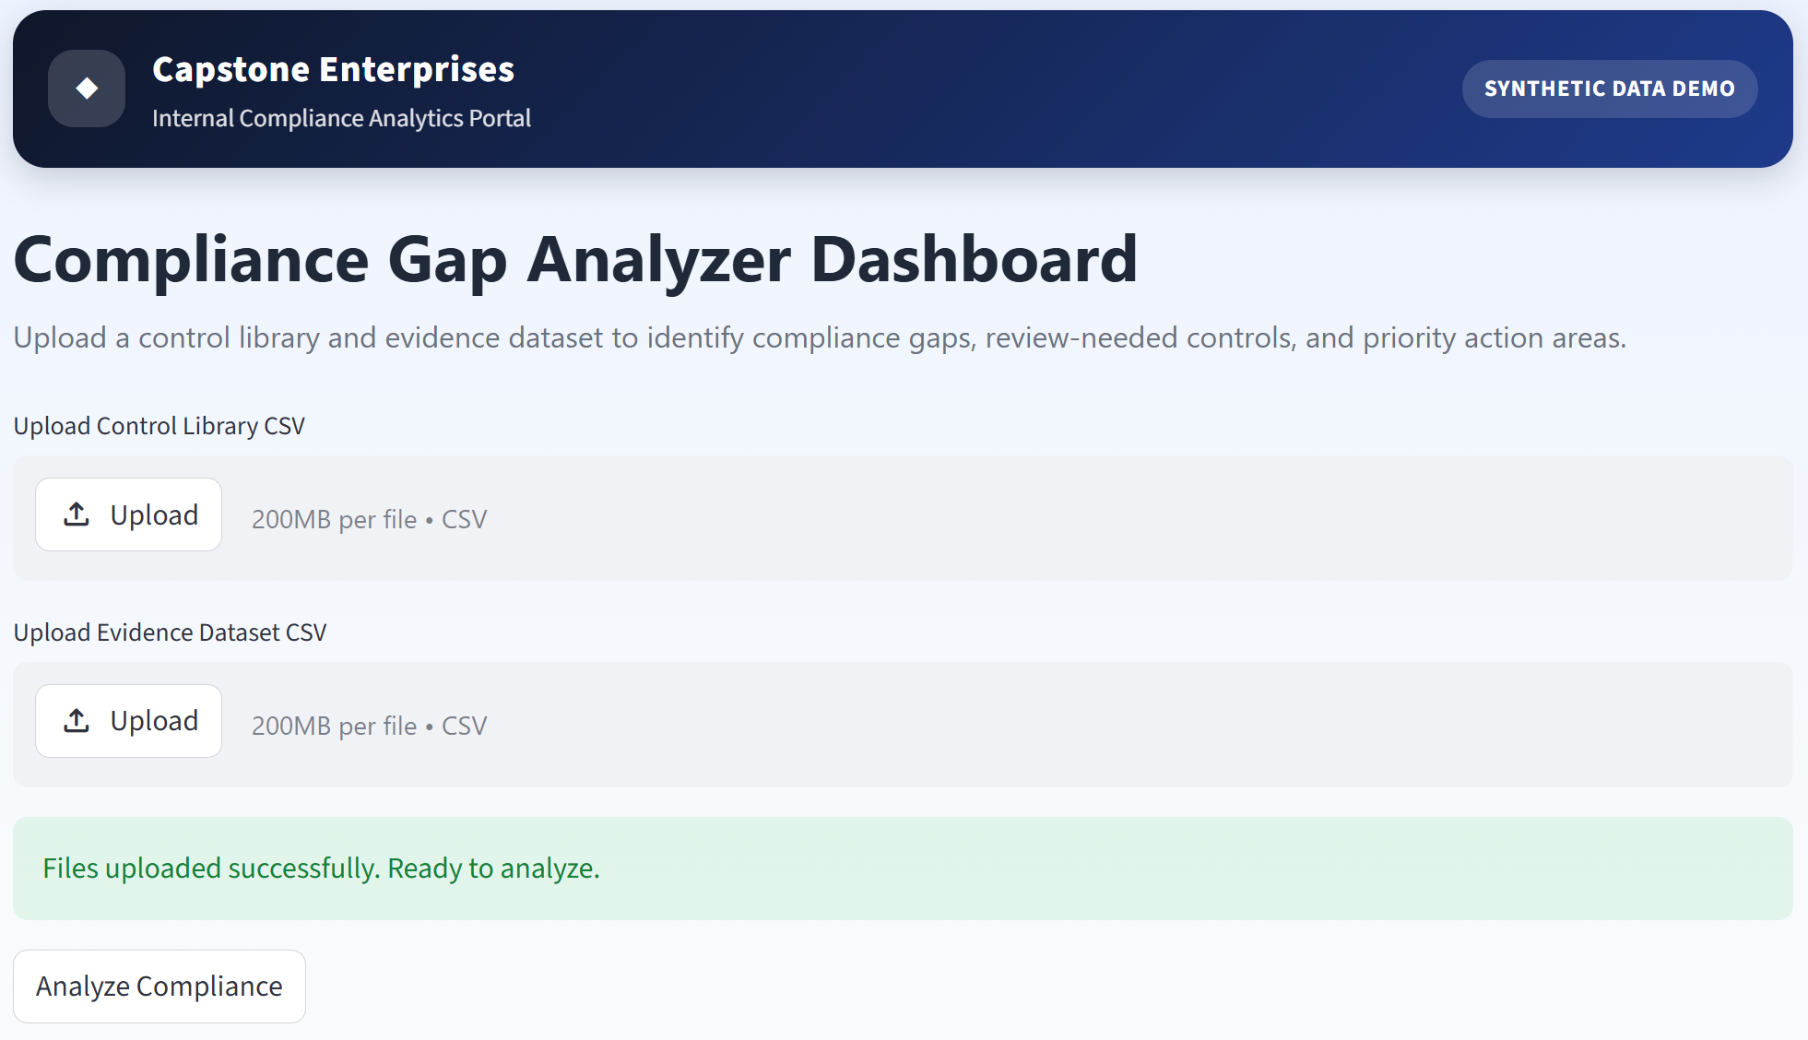
Figure 3: The initial user facing streamlit application screen where the user can upload the Control library and the Evidence Dataset.
The dashboard then turns those results into a business friendly view. It calculates the total number of controls analyzed, the number of Passed, Failed, and Needs Review controls, and the overall compliance percentage and then displays it for the user. This section is referred to as the “top metric cards” and their goal is to give an immediate summary of the company’s compliance position.
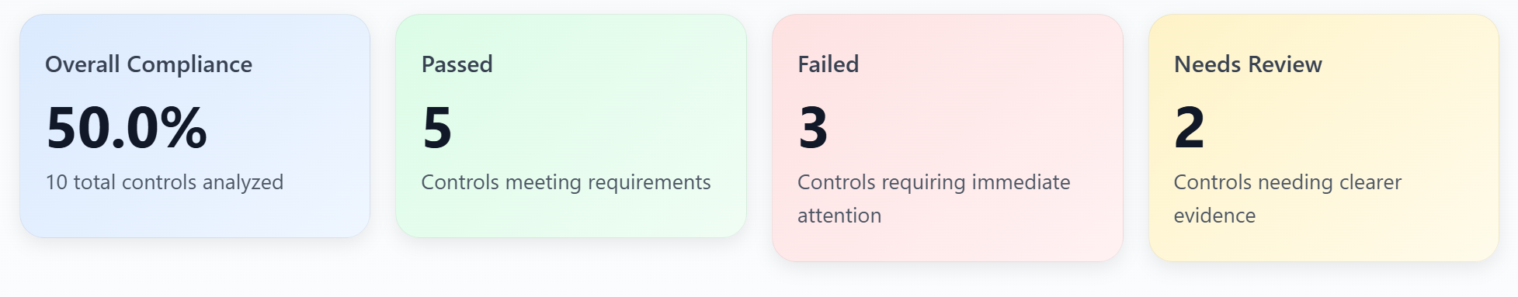
Figure 4: A screenshot of the Top Metrics Cards, demonstrating compliance calculations where an Overall Compliance percentage of 50% was demo’d. (5 controls are shown as Passed, 3 are shown as Failed and 2 are marked as Need Review.)
The visual sections of the dashboard were designed to help users understand the results quickly. The Compliance Risk Map uses a tree map to group controls by category, size each block by severity, and show the result for each control. This visual was incorporated to specifically to reflect on the content of the master’s program. It also plays an important role when considering the future of the prototype, where ideally it would be expanded from ten controls to a much larger SOX or ITGC matrix because users could quickly see where risk or uncertainty is concentrated.
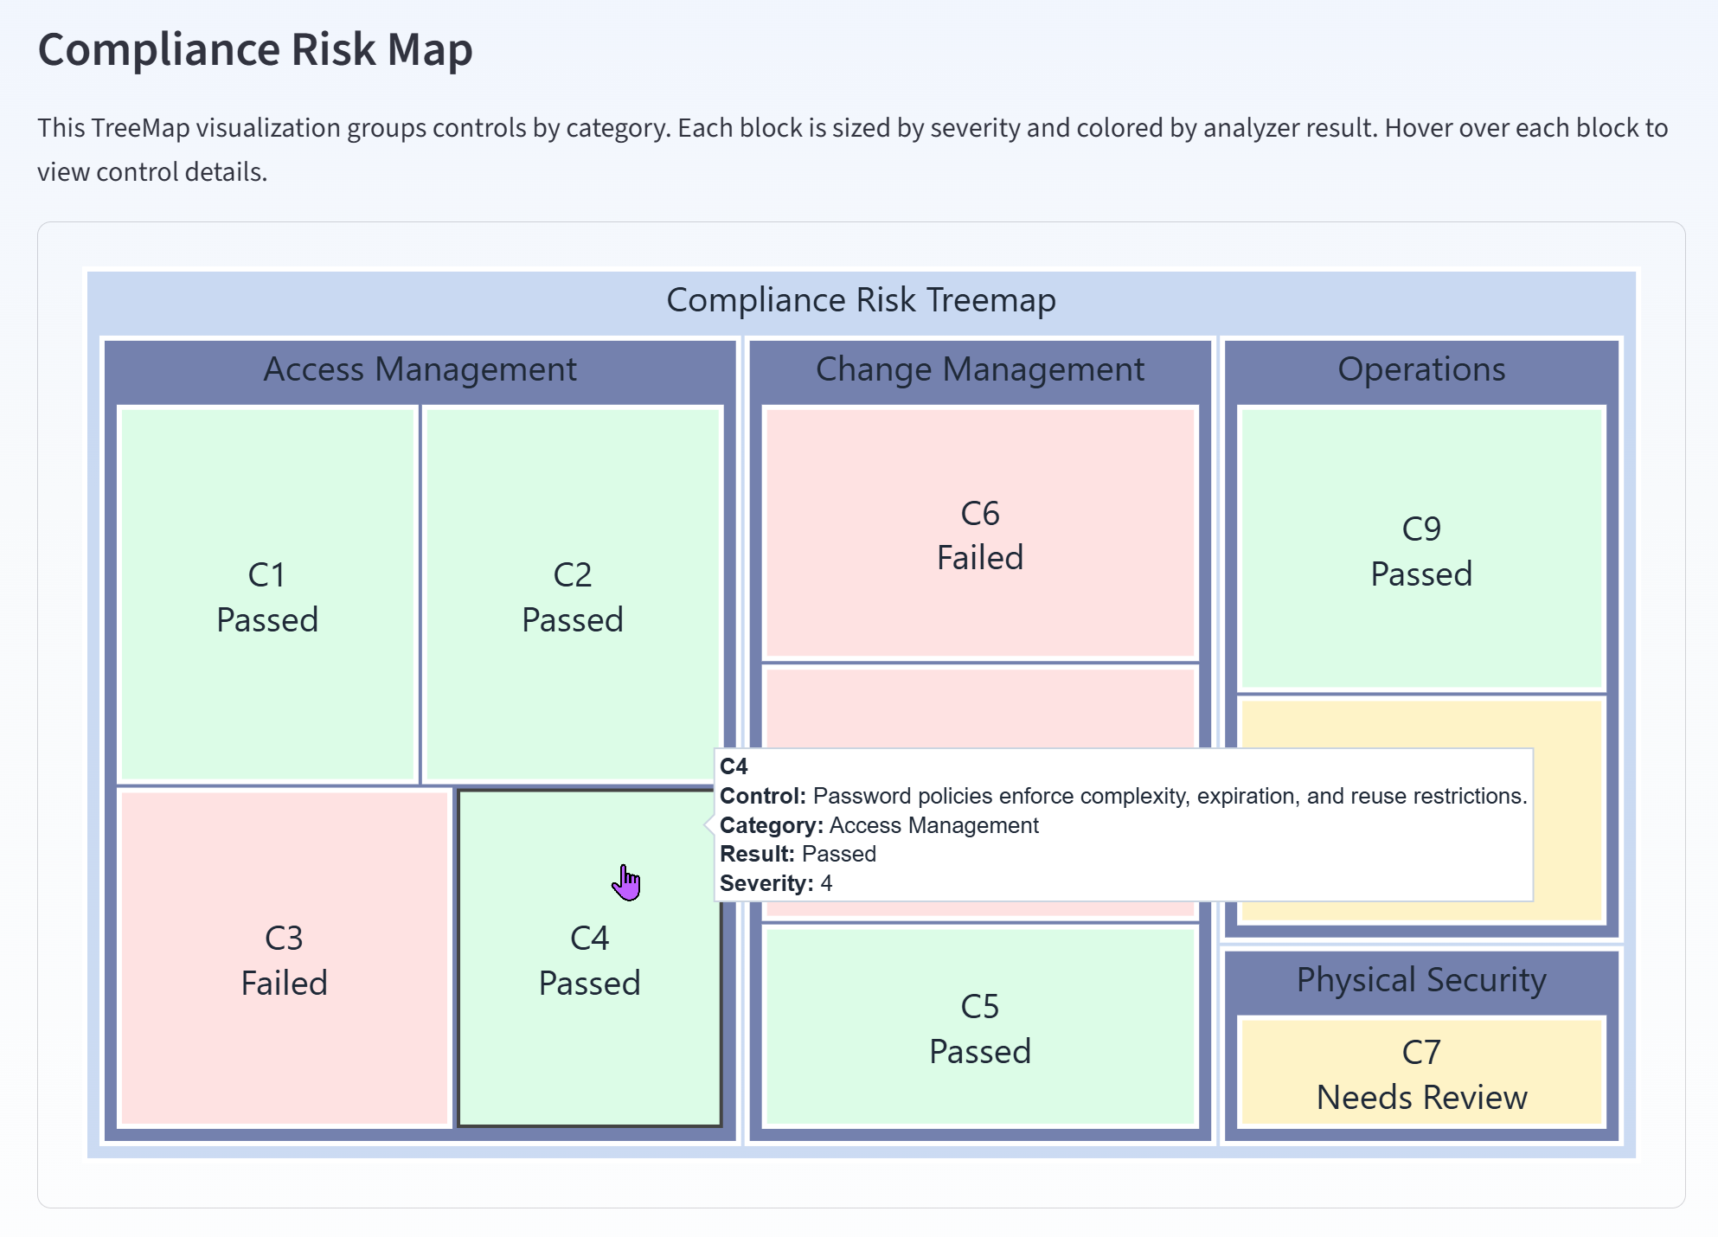
Figure 5: Front End Streamlit Application Treemap with hover feature detailing the control.

The prototype also includes action focused sections, such as the Priority Action Plan, ITGC Score Snapshot, and Company Focus Areas. These sections translate the analyzer results into practical next steps however each looks visually different. These were added to best reach each different type of user and cover different user preferences.
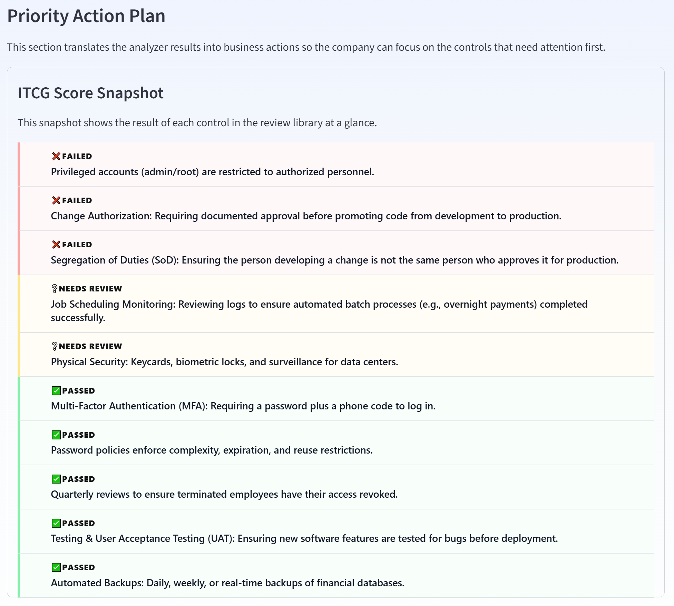
Figure 6: Screenshot of Priority Action Plan – ITGC Snapshot
Failed controls are treated as immediate action items, while controls marked as Needs Review are flagged for clearer evidence or additional documentation.
This was one of the most important parts of the prototype because the goal was not only to identify a result, but to help the user understand what to do next.
This is then further broken down in the Company Focus Area inside of Action Cards.
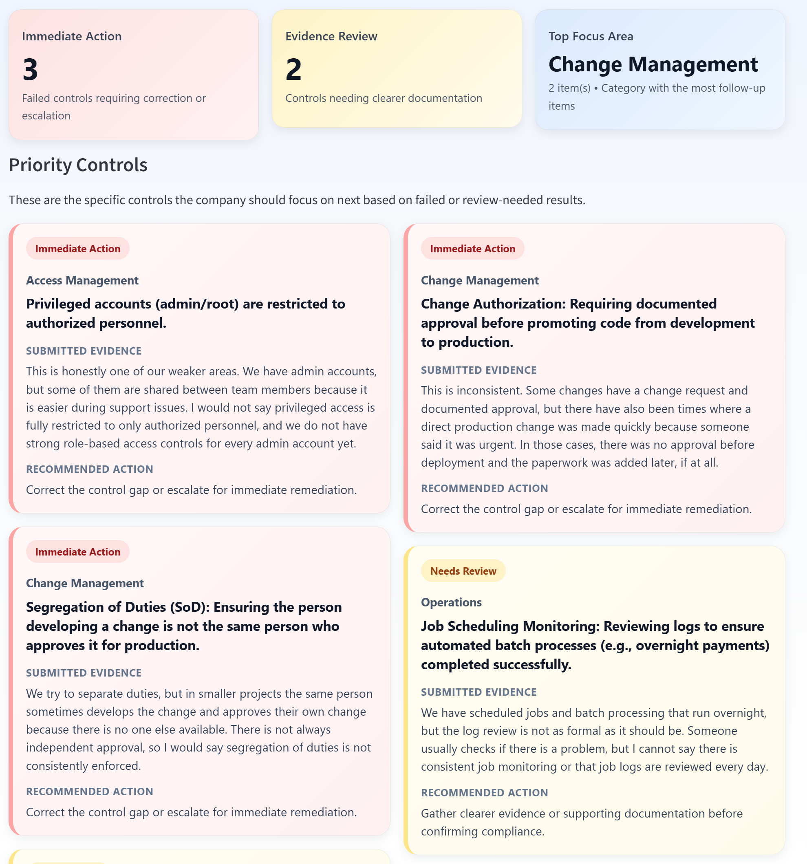
Figure 7: Screenshot of Action Item Cards
Finally, the application includes detailed result tables and a download option. The Full Results Table gives users a complete view of the analyzer output.
The download button allows the results to be exported as a CSV file for documentation, printing, or review.
Overall, the final prototype in streamlit includes rule-based analysis, file uploading, data processing, visualizations, and business action guidance. The end goal and project vision of visualizing and analyzing compliance was achieved and the results are presented in a dashboard that everyday users can understand.

Challenges and Future Improvements
One of the biggest challenges in this project was narrowing the original idea into something I could realistically build. At first, I pictured a tool that could read large SOX or ITGC spreadsheets in different formats, compare them against interview-style responses, and turn everything into a clean dashboard. That larger idea still matters to me, but for this capstone I had to start smaller and focusing on .csv uploads that gave me enough structure to build something functional without losing the heart of the original vision.
The largest limitation of the prototype is its scope and the way it interprets the data loaded into it. The analyzer currently focuses on ten ITGC controls, not a full SOX or ITGC matrix. This smaller scope was necessary for the capstone, but a real company would likely need many more controls, systems, and evidence types. A future improvement would be PDF and spreadsheet interpretation, allowing the tool to read larger control documents more directly. The project could also be expanded with AI or natural language processing to better interpret narrative responses and compare them against larger SOX or ITGC control matrices. These improvements would bring the project closer to the larger vision I started with.

Conclusion
This capstone started with a large idea and became a focused working prototype. The project moved through several stages. It began in Jupyter Notebook, where I built and tested the rules engine. That phase helped me work through text cleaning, keyword matching, weighted scoring, failure indicators, negation handling, and accuracy testing. Once the logic was working, I moved the project into Visual Studio Code and Streamlit so it could become a user-facing dashboard.
The final prototype allows a user to upload a control library and evidence dataset, run the analyzer, and view results through clear sections such as Passed, Failed, and Needs Review. It also includes summary metrics, a compliance risk map, priority action areas, detailed findings and a downloadable results file. These pieces connect back to the purpose of the project: helping companies review compliance evidence earlier and reducing the chance of being surprised as well as deficiencies during an external audit.
To me, the most meaningful part of this capstone was seeing how many parts of my master’s program came together in one project. It required data cleaning, synthetic data design, rules-based logic, visualizations such as treemaps, and the use of python and Jupyter Notebook. It also connected to my professional background in audit and compliance, where I have seen how important it is for companies to understand their control environment before issues become bigger problems.
The final result is not a complete enterprise audit platform, but it is a strong first version of the idea. It shows that narrative compliance evidence can be mapped to structured ITGC rules and turned into clear, visual, and actionable findings. More importantly, it showed me how a technical project can support a real business need by making complex information easier to understand and act on.

References
ISACA. (n.d.). COBIT. https://www.isaca.org/resources/cobit
Streamlit. (n.d.). Streamlit documentation. https://docs.streamlit.io/

